**DECISION TREE**

**Business Problem** = ﻿﻿A cloth manufacturing company is interested to know about the segment or attributes contributing to high sale.

* **Name of the File: -** Company_Data.csv
* **Size of the File: -** 20 KB
* **Necessary Data : -** 400 Observations, 11 Features.

**Exploratory data Analysis** =

* **Outliers: -**  Outliers are not presents.
* **Missing Value: -** Data don’t have Missing Values
* **Output:** - Categorical
* **Sampling:**- Stratified Sampling (80% - 20%)

**Building Decision Tree =** Building decision tree by considering entropy criterion.

* 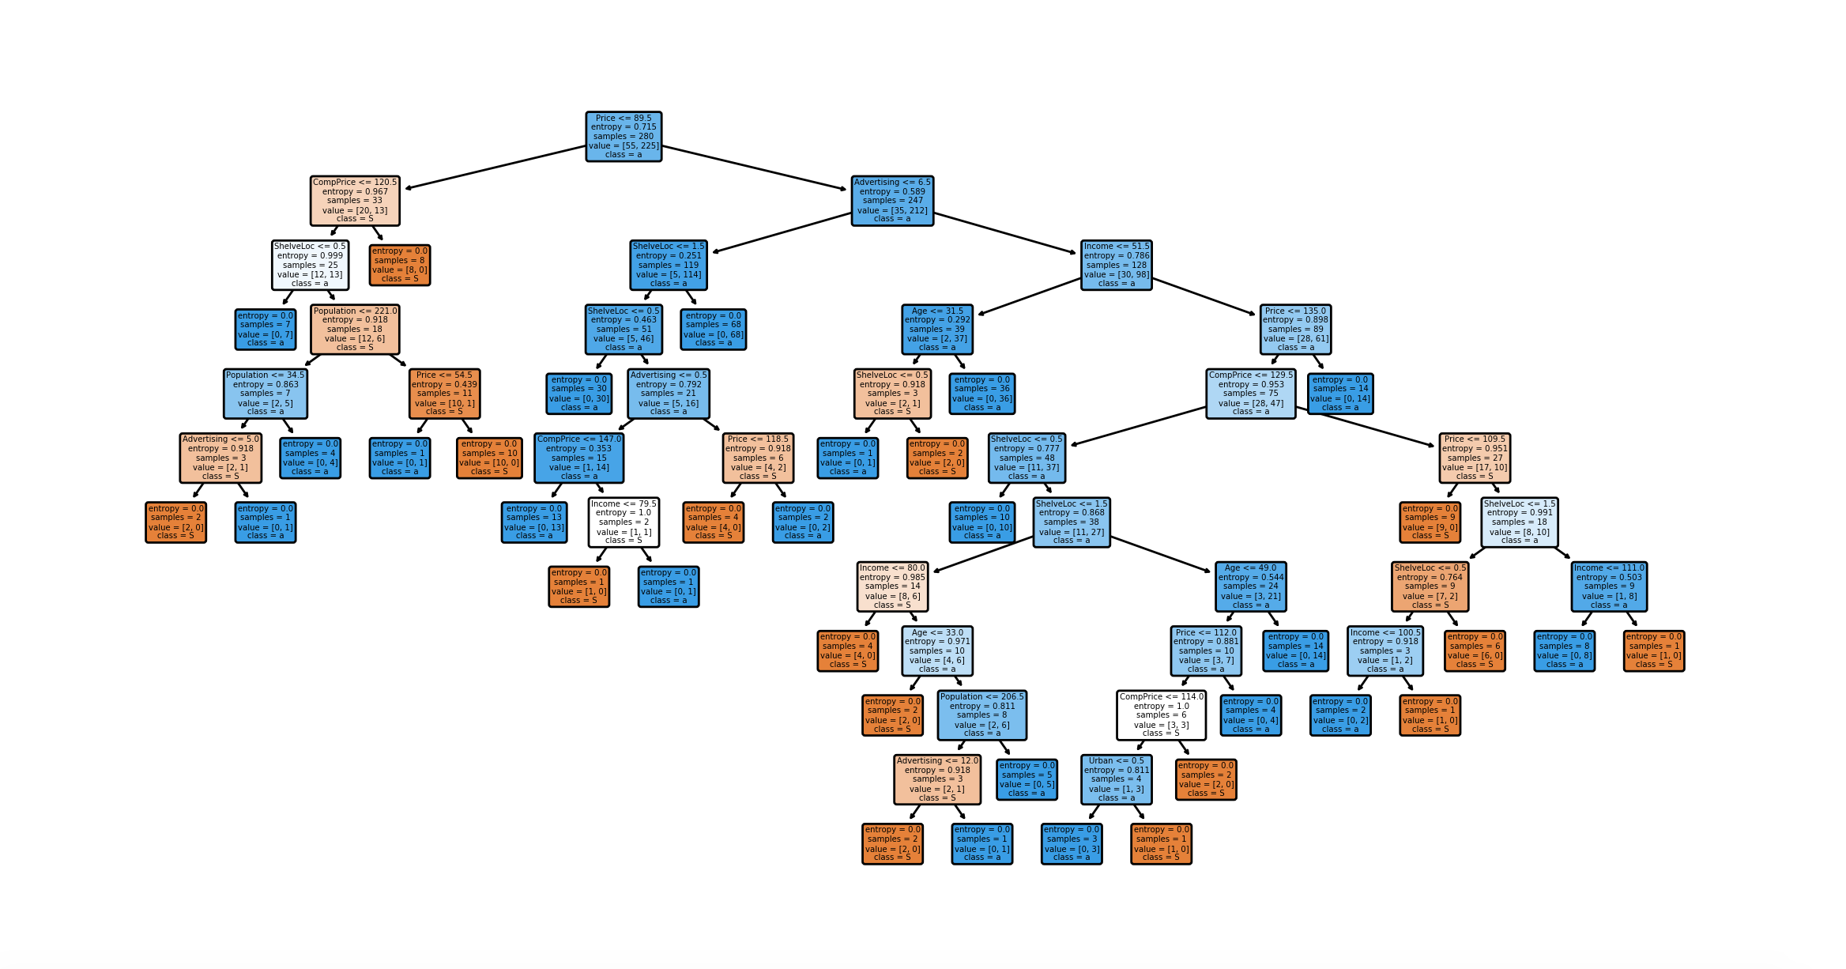**﻿Tree :-**

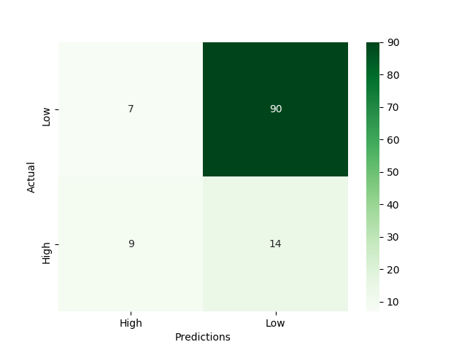

* **﻿Accuracy Score :-** 83 %
* **Confusion Matrix : -**

Accuracies of model on Train and Test data are high So we can use this model as Final model for Prediction.

**Python code file**: - [Company_Data Analysis.py](https://github.com/nilaydeshmukh0/Decision-Tree/blob/master/Company%20Data%20Analysis/Company_Data%20Analysis.py)